SENIOR FIVE TERM 2 GEOGRAPHY LESON NOTES 2026
TOPIC 1/2: Agriculture and Development
Competency: The learner gives written or oral advice to a certain community or country on appropriate farming types and techniques to be adopted to promote development through appraising the different types and methods of farming.

4.1 The Role of Agriculture in Development
Agriculture is the practice of cultivating land, raising crops, and rearing animals to produce food, raw materials, and other products essential for human life. Broadly, it is divided into arable farming (crop production) and livestock farming (animal rearing).
Arable Farming (Crop Production)
Meaning: Farming that focuses on growing crops on cultivated land.
Examples: Cereals (maize, wheat, rice), vegetables, fruits, cotton, and sugarcane.
Features:
- Requires fertile soils and favorable climate. o Often mechanized in developed countries, but may be subsistence-based in developing regions.
- Can be intensive (high input, high yield) or extensive (large areas, lower input).
Livestock Farming (Animal Rearing)
Meaning: Farming that involves raising animals for meat, milk, wool, hides, and labor.
Examples: Cattle, goats, sheep, pigs, poultry, and camels.
Features:
- Provides protein-rich food and raw materials for industries.
- Can be nomadic (moving herds in search of pasture) or commercial (large-scale ranching). o Often practiced in areas less suitable for crop farming.
Summary Table
Type of Agriculture | Focus | Examples | Key Features
Arable farming | Crop cultivation | Maize, rice, wheat, vegetables | Needs fertile soil, climate, can be intensive or extensive
Livestock farming | Animal rearing | Cattle, goats, poultry, sheep | Provides meat, milk, hides; nomadic or commercial
Why It Matters
- Both types are interdependent: crops provide feed for animals, and animals provide manure for crops.
- Understanding these types helps explain regional differences in farming practices (e.g., crop farming in fertile river valleys vs. livestock farming in semi-arid regions).

Contributions of Agriculture to Uganda’s Development
Agriculture is the backbone of Uganda’s economy and plays a central role in its development. It contributes to employment, food security, export earnings, industrial growth, and rural development, making it one of the most important sectors for the country’s progress.
- Employment & Livelihoods: It's the largest employer, providing jobs for the majority of Ugandans, especially in rural areas, and offers first jobs for many youth.
- Economic Growth: A major contributor to GDP, acting as the backbone for national development and economic stability.
- Government Revenue: Taxes from agricultural exports contribute to national income. The revenue supports funding for public services like education and healthcare.
- Foreign Exchange: Generates substantial export earnings, with coffee being a leading export, alongside growing non-traditional products like flowers, fish, and fruits.
- Poverty Reduction: Crucial for poverty alleviation, especially in rural areas, by providing income and food security.
- Value Addition & Industrialization: Creates opportunities for agro-processing (agroindustries), manufacturing of inputs (seeds, fertilizers), packaging, and logistics, driving industrial growth.
- Food Security: Ensures food supply for the nation through both subsistence and commercial farming.
- Supports Other Sectors: Stimulates growth in related sectors like transport, trade, finance (loans for farmers), and services.
- Environmental and Cultural Role: Promotes sustainable land use when managed well. And preserves traditional farming practices and cultural heritage.
In summary Agriculture is not just Uganda’s largest sector—it is the foundation of economic growth and social stability. Strengthening agriculture through modernization, value addition, and climate resilience is essential for Uganda to achieve its Vision 2040 goals.
Comparisons of the importance of agriculture in economies of developing and developed countries
Agriculture is important in both developing and developed countries, but its role differs. In developing countries like Uganda, agriculture is the backbone of the economy, providing jobs, food security, and export earnings. In developed countries, agriculture is highly mechanized, contributes less to GDP, but ensures food supply, technological innovation, and global trade. Comparison Table
Aspect | Developing Countries | Developed Countries
Employment contribution | Majority of workforce | Small fraction (<5%)
GDP contribution | Large share (20–40%) | Small share (<5%)
Technology and productivity | Labor-intensive, low yields | Mechanized, high yields
Food security role | Directly sustains population | Surplus, exports globally
Trade role | Raw product exports | Processed, high-value exports

Should African countries invest more or less in agriculture to achieve faster economic development and improved human welfare?
African countries should invest more in agriculture, but in a modernized and diversified way. Agriculture is the backbone of most African economies, employing the majority of the population and providing food security. However, traditional subsistence farming alone cannot drive rapid development. Strategic investment in agriculture—linked to industry, technology, and trade—can transform it into a powerful engine for economic growth and human welfare.
Why More Investment in Agriculture is Crucial
- Employment and Poverty Reduction: Agriculture employs 60–80% of Africa’s population, especially in rural areas. Modernizing farming creates jobs, raises incomes, and reduces poverty.
- Food Security and Nutrition: Investment in irrigation, improved seeds, and mechanization boosts yields. This reduces hunger and malnutrition, improving health and productivity.
- Industrial Growth: Agriculture supplies raw materials for industries (textiles, food processing, biofuels). Investing in agro-processing adds value, increasing GDP and exports.
- Export Earnings: Africa’s coffee, cocoa, tea, and horticulture are major global exports. Investing in value addition (processing locally) increases foreign exchange earnings.
- Rural Development: Agricultural investment improves rural infrastructure (roads, markets, electricity) which reduces rural-urban migration by creating opportunities in villages.
- Climate Resilience: Climate-smart agriculture helps countries adapt to droughts and floods. This protects ecosystems while sustaining livelihoods.
Balanced Perspective: More, But Smarter Investment

Invest More In…

Why It Matters

Modern farming technology

Boosts productivity and efficiency

Agro
-
processing industries

Adds value, creates jobs

Climate
-
smart pract
ices

Ensures sustainability

Education & training

Builds skilled farmers

Infrastructure (roads, irrigation)

Connects farmers to markets

What Investment Achieves

•

Modernization:

Brings new technology, better infrastructure (like irrigation), and efficient

practices.
- Job Creation: Generates employment across the entire value chain, from farm to market.
- Stable Returns: Offers long-term investment potential in an essential, always-needed industry.

Key Insight
- Investing less in agriculture would worsen poverty, hunger, and inequality.
- Investing more—but strategically— ensures agriculture is not just subsistence but a driver of industrialization, trade, and human development.
- Agriculture must be linked to diversification (manufacturing, services, digital economy) to achieve faster economic growth.

4.2 Subsistence Agriculture
Simple subsistence farming
It is a form of farming in which nearly all of the crops or livestock raised are used to maintain the farmer and the farmer's family, leaving little, if any, surplus for sale or trade.
The main forms of simple subsistence farming include
- Shifting cultivation
- Rotational bush fallowing
- Nomadic pastoralism

- Shifting cultivation

Shifting cultivation is a form of traditional subsistence cultivation carried out mainly in the tropical areas. It involves clearing of small pieces/tracts of land in the bush or forest using simple tools and burning, after which crops are grown for one or two seasons. When land losses fertility, the plot is abandoned and another is cleared through the same procedure. The predominantly grown crops are beans, maize, millet, yams, vegetables, etc. It is common backward communities where vast land still exist e.g. Democratic republic of Congo, Brazil, Zambia, Zimbabwe etc.

Characteristics of shifting cultivation
  - Farm plots are cleared through cut and burning of the bushes/ trees. - Plots are small and highly scattered.
  - Production is for home consumption
  - Simple tools such as machetes, digging sticks are used in clearing the land.
  - It's practiced in regions of low and sparse population.
  - Farm output is supplemented by fruit gathering and hunting of wild animals.
  - Annual crops such as are beans, maize, millet, yams, vegetables, are grown and no cash crops.
  - No scientific methods of farming are applied e.g. spraying.
  - Little attention is given to crops in the field until when they are ready for harvesting.
  - Once the land productivity declines, the plots are abandoned and virgin ones are cleared.

Advantages of shifting cultivation
  - Ensures cultivation of fertile land.
  - Limits accumulation of pests and diseases on cultivable land.
  - Minimizes soil erosion.

Clearing of land is often done by bush burning which adds fertility to the soil Bush burning kills pests and disease causing organisms.
  - Intercropping increases land yield and maintains soil fertility.
  - It is cheap because simple tools are used.
  - Abandoned plots are allowed to regain fertility.
  - Less time consuming, thus allows a farmer to carry out other activities such as hunting and fruit gathering.
Disadvantages of shifting cultivation - Requires vast land.
  - Leads to deforestation and land degradation.
  - Burning destroys soil structure and kills living organisms in the soil.
  - Small yields leads to low farmers’ income.
  - Hinders development of infrastructures such as roads, schools, health facilities.
  - Cannot support big population.
  - Absence of individual ownership of land limits credit facilitation.
  - No research is carried out to boost plant yield.

Factors for persistence of shifting cultivation
  - Existence of vast tracts of land for farming or for cultivation.
  - The limited market for agricultural products which does not favor large scale farming.
  - Unreliable transport facilities in remote areas to the market
  - Lack of education about better farming methods such as plantation farming - Limited capital that discourages commercial farming.
  - The communal land tenure ship system that discourages large scale
  - Limited skilled labour to engage in commercial farming in remote areas
  - Rudimentary technology /use of simple tools that cannot clear a big land for commercial farming
  - Steep relief in some areas cannot support large scale farming due to transport problems.
  - Declining soil fertility leads to abandonment of used plots of land.
  - Dependence on family labour limit commercial farming and favor shift cultivation
  - Natural hazards like foods, and drought destroy crops forcing farmers to shift to other pots of land
  - The system is flexible because it allows the growing a number of annual crops to feed the family.
  - Cultural orientation to shift cultivation.
  - Limited government intervention.
  - It allows time for other activities such as fishing, hunting, and gathering fruits.

Factors for decrease of shifting cultivation in Tropical Africa
  - Increase in population leading to decease of available land per person.
Increase in the demand for food to meet the needs of rapidly growing population.
Introduction of perennial crops such as coffee, cocoa cotton etc. that cannot be grown under shift cultivation.
  - Education of farmers against shift cultivation.
  - Introduction of plantation farming to grow cash crops like tea and sugar cane.
  - The introduction of monetary economy that required surplus production.
  - Government policy of reserving some land for forest and game reserve limits access to land - Changes in cultural attitudes.
  - Increased demand for agricultural products
  - Accessibility of funds for commercial farming.
  - Introduction of fertilizers and pesticides - Development of land tenure systems - Improvement in technology.

- Rotational bush fallowing
It is a type of farming where exhausted land is left to rest (fallow) to regain fertility and then recultivated. It is common in low populated countries such as tropical countries like Northern Nigeria, Zambia, Senegal, Ethiopia, South East Asia etc.

Characteristics of rotation bush fallowing
  - A piece of land is used and when crop yield declines, it is left to fallow in order to regain fertility before used again.
  - Farming is based on permanent and semi-permanent settlement.
  - Elementary tools are used in clearing land such as hoes, pangas etc.
  - Both food and cash crops are grown such maize, tobacco, vegetables etc.
  - Food production is mainly for consumption.
  - Family labour is employed.
  - Land is subdivided into a number of plots each of which is cultivated until it can no longer support crops and then left to fallow.
  - Farming depend on natural conditions.

- Nomadic pastoralism
Nomadic pastoralism is the practice of grazing large herd of livestock on natural pastures which involves large scale movement of people and their livestock in search of water and pasture. It common in the Sahel region which is an area south of Sahara but North of the Savannah region of Africa; stretching from West Africa around Senegal to the horn of Africa. It passes through Senegal, Mali, Northern Nigeria, Chad, Sudan, Ethiopia, Somalia etc.

The examples of the Nomads located here include:-
the Fulani of West Africa, the Nuer of Sudan and Ethiopia,
  - the Turkana of Northern Kenya etc.
  - The Masai of East Africa
  - Karamajong of Uganda

Characteristic features of nomadic pastoralism
  - The occupy area of low and unreliable rainfall.
  - The most valuable animals are cattle although sheep and goats are also common.
  - Traditional breed yield low quantity and low quality of beef and milk.
  - Livestock is kept for subsistence purpose.
  - Livestock depend on nature pasture.
  - Large flocks of animals are kept for prestige.
  - Communal grazing is carried out.
  - The animals provide the basic food from milk and blood.
  - Overstocking leads to over grazing.

Factors which have favored nomadic pastoralism in the Sahel region of Africa include
  - The harsh climate which is semi-arid characterized with low and unreliable rainfall of less than 500mm, with marked dry season, creating the need for constant search of surface water and pasture.
  - Poor quality of the vegetation cover, the vegetation is scanty, dry savannah, scrub and bush land, thickets. This offers poor quality pasture with a low carrying capacity.
  - A large expanse of land with a limited population leaves a large area of land where migrations can take place.
  - The cultural tendencies of the nomads. They are adamant/ conservative. They prefer nomadism as life style.
  - It is a source of live hood. They depend on live stock as a source of food for subsistence.
  - Poor transport facilities/remoteness away from centres of modernity.
  - Poor soils/ infertile soils which are not very suitable for crop farming, but can support some pastures of poor quality.
  - The land tenure system especially communal ownership of land provides land and allows mobility.
  - Existence of pests and diseases promotes mobility to avoid them.
  - Poor government policies e.g. lack of an effective program to develop these areas.
  - Poor local breeds which are low yielding but resistant to pests and diseases.
  - Absence of surface water promote mobility to look for water.
  - Low levels of education/ high levels of illiteracy.
  - Hostility of some of tribe discourages development projects in the region.
  - The plain relief favors mobility.
Limited capital resources for modernization of farming e.g. through irrigation, ranching etc.
Poor storage facilities for animal products.

Problems facing nomadic pastoralism
  - Shortage of water
  - Shortage of pasture
  - Poor breed animals
  - Pest and disease
  - Attacks from wild animals
  - Cattle rustling
  - Movements of long distances in search of water and pasture.

Measures being taken to solve problems facing nomadic pastoralism
  - Construction of water dam such as Valley dams to harvest water.
  - Introduction of cross breeding to improve cattle breeds.
  - Planting of fodder crops and grasses to supplement on natural pasture.
  - Introduction of cattle ranching schemes to regulate the number of cattle population.
  - Use of processed animal feeds.
  - Improvement of communication networks to enable marketing of animal products.
  - Setting up of milk collection centers with cooling facilities to encourage commercialization of livestock rearing.
  - Carrying out regular pests and disease control through dipping etc.
  - Provision of security to minimize cattle rustling.
  - Introduction of free education to break up traditional barriers and practices.
  - Setting up quarantine to restrict movement of sick/infected animals.
  - Availing services of extension workers to treat and teach modern methods to the pastoralists.
  - Carrying out research to improve on cattle breeds.

Importance of nomadic pastoralism
  - They use land that would otherwise be idle.
  - Provide milk, beef and hides to processing industries.
  - Create employment through processing industries.
  - Selling of beef and milk provide income to the pastoralists.
  - They diversify economy.
  - Dung is used as a building material.
  - Smoking of dung provides heat and scare away pests and vectors.
  - Pastoralists provide market to food growers.
  - Source of government revenue.

Policies and strategies aimed at improving subsistence agriculture in Uganda by 2025
Uganda's policies for subsistence farming focus on shifting to commercial agriculture through NAADS & Operation Wealth Creation (input distribution), boosting productivity with research & new seed varieties, improving extension services (e.g., training, farmer groups), promoting climate-smart & organic farming, enhancing market access (storage, processing), and strengthening value chains, all guided by the National Agriculture Policy (NAP) and Agriculture Sector Strategic Plan (ASSP).
Key Policies & Frameworks:
- National Development Plans (NDP I, II, III): Agriculture is prioritized as a growth sector in
Uganda’s long-term Vision 2040. Strategies include: Modernizing subsistence farming into commercial agriculture, Expanding irrigation and mechanization and Promoting agroindustrialization to add value to crops.
- National Agriculture Policy (NAP): Provides the overall framework for agricultural transformation. Focuses on food security, commercialization of farming, and sustainable resource use. Encourages farmers to grow and store adequate food, while promoting industrial and technological development.
- Agriculture Sector Strategic Plan (ASSP): Outlines specific activities like strengthening extension, supporting farmer groups (co-ops), and investing in infrastructure (silos, storage).
- National Organic Agriculture Policy (NOAP): Promotes research, processing, and marketing of organic products.
Key Strategies & Initiatives:
- Input & Technology Access:
  - NAADS (National Agricultural Advisory Services): Manages input distribution, promotes value chains, and links farmers to finance.
  - Operation Wealth Creation (OWC): Distributes seeds, tools, and livestock to boost household incomes.
  - Research & Development (NARO): Introduces high-yielding, drought-tolerant, and disease-resistant crop varieties (e.g., beans, maize).
- Extension & Training:
  - Strengthening extension staff, forming farmer groups (co-ops), and providing training on production, business, value addition, and nutrition.
  - Implementing skills-based approaches like Training of Trainers (TOT) and farmer training models (e.g., Sasakawa Africa Association).
- Market & Value Chain Development:
  - Investing in storage facilities (silos, warehouses) and processing equipment (mills, hullers).
  - Promoting Public-Private Partnerships (PPPs) and supporting farmer organizations.
- Sustainable Agriculture Practices
  - Policies encourage climate-smart agriculture to cope with droughts, floods, and soil degradation.
  - Promotes organic farming, agroforestry, and conservation agriculture.
  - Supports environmental sustainability alongside productivity
- Smallholder Transformation Strategy
  - Aimed at shifting smallholder farmers from subsistence to market-oriented production.
  - Promotes cooperatives, farmer groups, and access to credit.
  - Encourages adoption of improved seeds, fertilizers, and modern farming techniques
- Climate Resilience & Sustainability:
  - Promoting Climate-Smart Agriculture (CSA) through projects like CRAFT, focusing on soil conservation and diversification.
  - Supporting organic farming and integrated approaches like Regenerative Agriculture (RA).
- Infrastructure and Market Access
  - Expanding rural roads, storage facilities, and irrigation systems.
  - Linking farmers to domestic and regional markets.
  - Supporting agro-processing industries to reduce post-harvest losses.
- Institutional & Sectoral Support:
  - Strengthening the Ministry (MAAIF) and research bodies (NARO, NAGRC&DB).
  - Developing policies for specific sub-sectors (seed, fertilizer, coffee).
By integrating these strategies, Uganda aims to move smallholder farmers from subsistence to market-oriented, profitable, and sustainable commercial agriculture.

Success Uganda has so far achieved from improving subsistence farming by 2025
By 2025, Uganda has made notable progress in improving subsistence farming, though challenges remain. The government’s policies, programs, and farmer-led innovations have helped transform parts of the agricultural sector from purely subsistence to more commercial, resilient, and productive systems.
Key Successes Uganda Has Achieved by 2025
- Increased Food Security: Expansion of Operation Wealth Creation (OWC) and input distribution (seeds, fertilizers, and livestock) has boosted household food production. This has reduced hunger and malnutrition in many rural communities.
- Growth in Agro-Industrialization: Implementation of National Development Plan III (NDP III) prioritized agro-industrialization. More farmers are now linked to agro-processing industries (coffee, dairy, maize milling), reducing post-harvest losses.
- Expansion of Market-Oriented Farming: Smallholder farmers increasingly participate in cooperatives and farmer groups, giving them access to credit and markets which has led to a rise in cash crop production (coffee, tea, maize, beans) for both domestic and export markets.
- Improved Rural Incomes: Household incomes have grown as farmers sell surplus produce leading to decline in poverty rates, though unevenly across regions.
- Climate-Smart Agriculture Adoption: Wider use of drought-resistant crops, irrigation schemes, and agroforestry. Farmers are better prepared for climate shocks like floods and prolonged droughts.
- Infrastructure Development: Rural roads, storage facilities, and irrigation projects have expanded. While improved access to markets and reduced post-harvest losses.
- Export Growth: Coffee exports remain Uganda’s top foreign exchange earner, with improved quality and branding. Growth in horticulture exports (fruits, vegetables, flowers) to regional and global markets.

Summary Table
Area of Success | Achievements by 2025
Food security improvements | More households producing enough food
Agro-industrial growth | Expansion of processing industries
Market-oriented farming expansion | Rise in cash crop production
Rural income improvements | Higher household incomes, reduced poverty
Climate-smart agriculture adoption | Wider use of resilient practices
Infrastructure development | Better roads, irrigation, storage
Export growth | Increased coffee and horticulture exports
Key Insight
Uganda’s success lies in shifting subsistence farming toward commercialization and resilience. While agriculture still faces challenges—like rapid population growth, climate change, and limited mechanization—the progress by 2025 shows that subsistence farming can evolve into a driver of national development when supported by strong policies and farmer innovation.

Case studies of countries or regions with successful interventions to improve subsistence farming
Two strong case studies of successful interventions to improve subsistence farming are Kenya
(nutrition-sensitive agriculture programs with home gardens and livestock) and Honduras (community-based farming and nutrition projects). Both show how targeted policies and grassroots strategies can transform subsistence farming into more productive, resilient, and welfare-enhancing systems.
Case Study 1: Kenya – Nutrition-Sensitive Agriculture
Intervention: Programs promoted home gardens and small-scale livestock rearing, especially targeting women.
Strategies:
- Training households in cultivating diverse crops suited to local conditions. o Encouraging poultry and goat rearing for protein supply. o Linking agriculture with nutrition education to improve diets.
Impact:
- Increased household food production and dietary diversity. o Empowered women by giving them control over food and income. o Reduced malnutrition risks in rural communities.
Case Study 2: Honduras – Community-Based Farming & Nutrition
Intervention: Integrated agriculture and nutrition programs focusing on kitchen gardens, small livestock, and community training.
Strategies:
- Promoted crop diversification (vegetables, legumes, fruits). o Supported smallholder farmers with training in sustainable practices. o Linked farming to school feeding programs to improve child nutrition.
Impact:
- Boosted household food security and resilience. o Improved children’s diets and reduced micronutrient deficiencies. o Strengthened community cooperation in farming and nutrition.
Comparison Table
Country/Region | Intervention | Strategies | Impact
Kenya | Nutrition-sensitive agriculture | Home gardens, livestock, women’s empowerment | Improved food diversity, reduced malnutrition
Honduras | Community-based farming & nutrition | Kitchen gardens, crop diversification, school feeding | Better child nutrition, stronger food security
Lesson Uganda can learn from the case studies
Both Kenya and Honduras show that subsistence farming can be improved through integrated approaches—combining crop diversification, livestock rearing, nutrition education, and community empowerment. These interventions not only increase yields but also enhance human welfare, resilience, and long-term sustainability.

A sample of Farmers’ Development Manifesto for Uganda Vision
To transform Uganda’s farming communities from subsistence-based livelihoods into prosperous, resilient, and sustainable agricultural systems that ensure food security, economic growth, and improved human welfare.
Core Principles
- Equity: Every farmer, regardless of gender, age, or location, deserves equal access to resources.
- Sustainability: Farming practices must protect the environment and secure resources for future generations.
- Innovation: Embrace modern technologies and knowledge to boost productivity.
- Community Empowerment: Farmers should be active decision-makers in shaping agricultural policies.
Key Challenges Faced by Farmers
- Low productivity due to reliance on traditional methods.
- Limited access to credit, markets, and modern inputs.
- Climate change impacts (droughts, floods, pests).
- Poor infrastructure (roads, storage, irrigation).
- Weak extension services and farmer training.
- Post-harvest losses and lack of value addition.
Strategic Interventions
- Modernization of Farming
  - Provide affordable mechanization tools (tractors, irrigation pumps).
  - Promote improved seeds and fertilizers.
  - Encourage climate-smart agriculture (drought-resistant crops, agroforestry).
- Access to Finance and Markets
  - Establish farmer cooperatives to pool resources and negotiate better prices.
  - Expand microfinance and credit schemes tailored for smallholders.
  - Build local markets and storage facilities to reduce post-harvest losses.
- Infrastructure Development
  - Improve rural roads to connect farmers to markets.
  - Expand irrigation systems to reduce dependence on rainfall.
  - Invest in electricity and digital connectivity for rural communities to reduce rural-urban migration
- Farmer Education and Extension Services
  - Strengthen agricultural extension programs to train farmers in modern practices.
  - Promote digital platforms for sharing farming knowledge.
  - Encourage youth participation in agriculture through vocational training.
- Value Addition and Agro-Industrialization
  - Support agro-processing industries (coffee, maize, dairy, fruits).
  - Encourage branding and certification for Ugandan products in global markets. • Reduce reliance on raw exports by promoting local processing.
- Climate Resilience and Environmental Protection
  - Promote sustainable land management to prevent soil erosion.
  - Encourage tree planting and agroforestry.
  - Develop early warning systems for climate disasters.
Expected Outcomes
  - Increased farmer incomes and reduced poverty.
  - Improved food security and nutrition.
  - Stronger rural economies with better infrastructure.
  - Resilient farming communities able to withstand climate shocks.
  - Uganda positioned as a regional leader in agro-industrialization.
Call to Action
This manifesto calls upon:
  - Government to prioritize agriculture in budgets and policies.
  - Private sector to invest in agro-processing and rural infrastructure.
  - Communities to embrace cooperatives and sustainable practices. • Youth and women to take leadership roles in modern farming.
In summary: This manifesto envisions a Uganda where farmers are not just surviving but thriving—where agriculture is modern, profitable, and sustainable, driving both local and national development.

4.3 Commercial Agriculture
Commercial agriculture (also called commercial farming or agribusiness) is large-scale farming where crops and livestock are produced primarily for sale and profit in local, national, or international markets, rather than for family consumption.
Meaning of Commercial Agriculture
Definition: Farming aimed at producing crops and animals for profit-making rather than subsistence. Key Features:
- Large-scale production.
- Use of modern technology, mechanization, fertilizers, and improved seed varieties. o Market-oriented, targeting domestic and export markets. o Often involves monoculture (single crop focus) or specialized livestock rearing.
Difference from subsistence farming: Subsistence farming focuses on survival and household needs, while commercial farming focuses on profit and trade.
Types of Commercial Agriculture
- Arable farming: Large-scale cultivation of crops like wheat, maize, rice, sugarcane, and cotton.
- Livestock farming: Rearing animals such as cattle, pigs, poultry, and sheep for meat, milk, eggs, and hides.
- Mixed farming: Combination of crops and livestock on the same farm.
- Plantation farming: Large estates producing cash crops (tea, coffee, bananas, palm oil) for export.
- Horticulture farming: Commercial production of fruits, vegetables, and flowers. Importance of Commercial Agriculture
Aspect | Contribution
Economic growth | Generates income and foreign exchange through exports
Employment | Creates jobs in farming, processing, and distribution
Food supply | Provides surplus food for urban populations
Industrial linkages | Supplies raw materials for agro-industries
Technology adoption | Encourages mechanization and innovation

Conditions favoring commercial agriculture
Commercial agriculture is favored by a combination of natural (physical) and human (socioeconomic) conditions that enable large-scale, profitable production.
Natural (Physical) Factors
- Climate: Adequate and reliable rainfall, suitable temperatures, and sufficient sunlight are crucial. Regions with moderate, predictable climates and long growing periods are ideal for maximizing yields.
- Soil: The presence of fertile, nutrient-rich, and well-drained soils is essential for healthy plant growth.
- Topography: Flat or gently sloping land is preferred as it is easier to cultivate, minimizes soil erosion, and is suitable for mechanization and irrigation systems.
- Water Supply: Consistent access to water sources, whether through reliable rainfall, rivers, or efficient irrigation systems (e.g., drip irrigation), is vital for intensive production.
Human (Socio-Economic) Factors
- Large-scale Land Availability: Commercial farming operates on vast tracts of land to achieve economies of scale and maximize output.
- Capital Investment: Significant financial resources are required to invest in land, advanced machinery (tractors, harvesters, etc.), quality inputs (high-yield seeds, fertilizers, pesticides), and infrastructure. Access to funding and loans is important.
- Technology and Mechanization: The use of modern technology, precision farming techniques and efficient equipment boosts productivity, optimizes resource use, and reduces labor costs.
- Infrastructure: Good transportation networks (roads, railways, ports) are necessary for efficiently moving inputs to the farm and produce to markets (local, national, and international).
- Market Accessibility and Demand: Proximity to large population centers or access to robust supply chains and markets ensures products can be sold for profit. Market research to identify high-demand, high-value crops is a key factor.
- Skilled Labor and Expertise: Availability of both skilled and unskilled labor with the necessary knowledge of modern agricultural practices and business management is important.
- Supportive Government Policies: Favorable government policies such as subsidies, training programs, and regulations that support market accessibility and trade can encourage commercial agriculture.
Difference between intensive and extensive commercial agriculture
The main difference is that intensive commercial agriculture relies on high inputs (labor, capital, technology) to maximize yields on small areas of land, while extensive commercial agriculture uses large areas of land with lower inputs per unit area to produce crops or livestock.
Intensive vs. Extensive Commercial Agriculture
Intensive Commercial Agriculture
- High input use: Heavy reliance on fertilizers, pesticides, irrigation, and machinery.
- Small land area: Focuses on maximizing productivity per hectare.
- Labor and capital intensive: Requires significant investment and workforce.
- High yields: Produces large amounts of crops or livestock relative to land size.
Examples: Market gardening, dairy farming near cities, and greenhouse farming.
Extensive Commercial Agriculture
- Low input use: Minimal reliance on fertilizers or technology compared to intensive farming.
- Large land area: Expands cultivation or grazing over vast tracts of land.
- Labor and capital extensive: Less labor and investment per unit of land.
- Lower yields per hectare: But total output can be high due to sheer land size.
Examples: Wheat farming in the prairies, cattle ranching, sheep grazing in Australia.

Comparison Table
Aspect | Intensive Commercial Agriculture | Extensive Commercial Agriculture
Land use | Small plots | Large tracts
Inputs | High fertilizers, irrigation, machinery | Low inputs per unit area
Labor | High labor per hectare | Low labor per hectare
Yield | High yield per hectare | Low yield per hectare
Examples | Vegetable farming, dairy near cities | Wheat farming, cattle ranching

Advantages of commercial agriculture
The main advantages of commercial farming are high productivity, economic growth, employment creation, and reliable food supply. It supports both local and global markets by producing large quantities of crops and livestock efficiently.
Key Advantages of Commercial Farming
- High productivity: Large-scale use of machinery, fertilizers, and improved seeds leads to higher yields.
- Economic growth: Contributes significantly to national GDP, trade, and rural development.
- Employment opportunities: Provides jobs in farming, processing, transport, and marketing.
- Food security: Ensures a steady supply of food to meet growing population demands.
- Technological advancement: Encourages innovation in irrigation, biotechnology, and mechanization.
- Market orientation: Farmers earn profits by producing for local and international markets.
- Infrastructure development: Stimulates investment in roads, storage, and transport
facilities
Disadvantages of Commercial Agriculture
The main disadvantages of commercial agriculture are environmental degradation, loss of biodiversity, soil depletion, heavy chemical use, and vulnerability to market fluctuations.
Key Disadvantages of Commercial Agriculture
- Soil depletion: Continuous monocropping and overuse of fertilizers exhaust soil nutrients, reducing long-term fertility.
- Environmental pollution: Heavy use of pesticides, herbicides, and fertilizers contaminates water and air, harming ecosystems.
- Loss of biodiversity: Large-scale monoculture farming reduces plant and animal diversity, disrupting ecological balance.
- High resource consumption: Intensive irrigation and mechanization demand vast amounts of water and energy.
- Market dependency: Farmers are vulnerable to global price fluctuations, which can cause financial instability.
- Social inequality: Wealthy agribusinesses dominate, often marginalizing smallholder farmers.
- Health risks: Chemical residues in food and exposure to pesticides pose risks to human health.
- Climate change contribution: Large-scale farming increases greenhouse gas emissions through machinery, fertilizers, and deforestation.
Comparison Table: Advantages vs. Disadvantages
Aspect | Advantages of Commercial Farming | Disadvantages of Commercial Farming
Productivity | High yields from modern inputs | Soil depletion due to overuse of chemicals
Economy | Boosts GDP and trade | Market dependency exposes farmers to price fluctuations
Employment | Creates jobs in multiple sectors | Labor exploitation possible in some regions
Food supply | Reliable food availability | Environmental impact from monocropping and pesticides

4.4 Agricultural Modernization
Features of modern agriculture
Modern agriculture is characterized by advanced technology, high productivity, sustainability practices, and market orientation. It integrates science and innovation to maximize yields while minimizing environmental impact.

Key Features of Modern Agriculture
- Use of advanced technology: GPS-guided tractors, drones, sensors, and automated irrigation systems improve efficiency.
- Precision farming: Data-driven techniques optimize water, fertilizer, and pesticide use to reduce waste.
- High productivity: Improved seed varieties, mechanization, and biotechnology increase yields per hectare.
- Sustainability focus: Practices like crop rotation, organic inputs, and reduced chemical use aim to protect soil and ecosystems.
- Market orientation: Production is geared toward supplying local and global markets, not just subsistence.
- Integration of biotechnology: Genetically modified crops and hybrid seeds enhance resistance to pests and climate stress.
- Efficient resource use: Smart irrigation and soil health monitoring reduce water and nutrient wastage.
- Global connectivity: Farmers access international markets, digital platforms, and supply chains.
Comparison Table: Traditional vs. Modern Agriculture
Aspect | Traditional Agriculture | Modern Agriculture
Technology | Simple tools | Advanced machinery & digital tools
Productivity | Low yields | High yields per hectare
Sustainability | Natural methods | Eco-friendly innovations
Market focus | Subsistence farming | Commercial & global markets
Resource use | Manual irrigation | Precision irrigation & sensors
Policies and programs aimed at modernizing agriculture in Uganda
Uganda is modernizing agriculture through national policies, climate-smart programs, seed and mechanization initiatives, and farmer support schemes. These efforts aim to boost productivity, sustainability, and market competitiveness.
Major Policies and Programs in Uganda
- National Agriculture Policy (NAP): Provides the overall framework for agricultural transformation, focusing on commercialization, food security, and sustainable practices.
- National Seed Policy: Ensures access to quality seeds, promotes certification, and strengthens seed systems for higher yields.
- Uganda Climate Smart Agriculture Transformation Project (UCSATP): A World Banksupported program promoting resilience, sustainable land use, and adaptation to climate change.
- National Agricultural Extension Policy: Expands farmer training, advisory services, and access to modern techniques.
- Mechanization and Irrigation Programs: Government initiatives to provide tractors, irrigation schemes, and post-harvest technologies to farmers.
- Agro-industrialization Strategy: Part of Uganda’s Vision 2040, focusing on value addition, agro-processing, and linking farmers to markets.
- Sustainable Agriculture Practices: Policies encouraging organic farming, soil conservation, and biodiversity protection.
Policy Focus Areas
Policy/Program | Objective | Key Impact
National Agriculture Policy | Commercialize farming | Boost productivity & incomes
National Seed Policy | Quality seed access | Higher yields & resilience
Climate Smart Agriculture  Project | Adapt to climate change | Sustainable farming systems
Extension Policy | Farmer training | Knowledge transfer & innovation
Mechanization/Irrigation | Modern tools & water use | Reduced labor, improved efficiency
Agro-industrialization Strategy | Value addition | Stronger markets & exports
Sustainability Policies | Eco-friendly farming | Soil health & biodiversity
Challenges and Trade-offs
- Funding gaps: Many programs rely on donor support and face budget constraints.
- Implementation hurdles: Limited infrastructure and weak coordination slow progress.
- Farmer adoption: Smallholders may struggle with costs of modern inputs.
- Climate risks: Extreme weather events still threaten productivity despite resilience programs.
Policies and programs aimed at modernizing agriculture in Uganda
Uganda is modernizing agriculture through national policies, seed and mechanization programs, climate-smart initiatives, and agro-industrialization strategies. These efforts aim to transform smallholder farming into a more productive, sustainable, and market-oriented sector.
Key Policies and Programs in Uganda
- National Agriculture Policy (NAP): Provides the framework for transforming agriculture from subsistence to commercial, emphasizing food security, value addition, and sustainability.
- National Seed Policy: Ensures farmers access certified, high-quality seeds to improve yields and resilience.
- Uganda Climate Smart Agriculture Transformation Project (UCSATP): Supported by the World Bank, this program promotes climate-resilient farming, sustainable land management, and adaptation to climate change.
- National Agricultural Extension Policy: Expands farmer training, advisory services, and access to modern techniques.
- Mechanization and Irrigation Programs: Government initiatives to provide tractors, irrigation schemes, and post-harvest technologies to farmers.
- Agro-industrialization Strategy: Part of Uganda’s Vision 2040, focusing on value addition, agro-processing, and linking farmers to regional and global markets.
- Sustainable Agriculture Practices: Policies encouraging organic farming, soil conservation, and biodiversity protection.
Policy Focus Areas
Policy/Program | Objective | Key Impact
National Agriculture Policy | Commercialize farming | Boost productivity & farmer incomes
National Seed Policy | Quality seed access | Higher yields & resilience
Climate Smart Agriculture  Project | Adapt to climate change | Sustainable farming systems
Extension Policy | Farmer training | Knowledge transfer & innovation
Mechanization/Irrigation | Modern tools & water use | Reduced labor, improved efficiency
Agro-industrialization Strategy | Value addition | Stronger markets & exports
Sustainability Policies | Eco-friendly farming | Soil health & biodiversity
Challenges and Trade-offs
  - Funding gaps: Many programs rely on donor support and face budget constraints.
  - Implementation hurdles: Limited infrastructure and weak coordination slow progress.
  - Farmer adoption: Smallholders may struggle with costs of modern inputs.
  - Climate risks: Extreme weather events still threaten productivity despite resilience programs.
Steps needed in Uganda to modernize agriculture
Uganda needs to modernize agriculture by investing in mechanization, improving seed systems, expanding irrigation, strengthening extension services, promoting climate-smart practices, and enhancing market access.
Key Steps for Modernizing Agriculture in Uganda
- Mechanization and technology adoption: Provide affordable access to tractors, harvesters, and digital tools to reduce reliance on manual labor.
- Improved seed and input systems: Strengthen seed certification, distribution, and access to fertilizers and pesticides to boost yields.
- Expansion of irrigation: Develop water management infrastructure to reduce dependence on rainfall and mitigate climate risks.
- Strengthening extension services: Train and deploy more agricultural extension workers to transfer modern knowledge and practices to farmers.
- Climate-smart agriculture: Promote sustainable practices such as crop rotation, agroforestry, and soil conservation to adapt to climate change.
- Agro-industrialization: Invest in agro-processing industries to add value, reduce postharvest losses, and create jobs.
- Market access and infrastructure: Improve rural roads, storage facilities, and market linkages to connect farmers to local and global markets.
- Financing and credit access: Expand affordable credit schemes and insurance products to support smallholder farmers.
- Policy and institutional support: Strengthen coordination among government agencies, private sector, and farmer cooperatives for effective implementation.

Priority Areas for Uganda’s Agricultural Transformation
Step | Objective | Impact
Mechanization | Reduce manual labor | Higher efficiency & yields
Seed systems | Access to quality inputs | Increased productivity
Irrigation | Reliable water supply | Climate resilience
Extension services | Farmer training | Knowledge transfer
Climate-smart practices | Sustainable farming | Soil & ecosystem protection
Agro-industrialization | Value addition | Rural jobs & exports
Market access | Better infrastructure | Reduced losses, higher incomes
Financing | Affordable credit | Empower smallholders
Policy support | Strong institutions | Effective implementation
Stakeholders needed to modernize agriculture in Uganda
Modernizing agriculture in Uganda requires collaboration among government, farmers, private sector, financial institutions, NGOs, research bodies, and international partners. Each stakeholder plays a unique role in driving productivity, sustainability, and commercialization.
Key Stakeholders in Uganda’s Agricultural Modernization
- Government of Uganda: Provides policies, subsidies, infrastructure, and extension services to support modernization.
- Farmers and Farmer Cooperatives: Adopt modern practices, organize collectively, and drive production at the grassroots level.
- Private Sector & Agribusinesses: Invest in agro-processing, mechanization, and supply chains to add value and create markets.
- Financial Institutions: Offer credit, insurance, and investment capital to enable farmers to access modern inputs and technologies.
- Non-Governmental Organizations (NGOs): Provide training, advocacy, and support for sustainable and climate-smart agriculture.
- Research and Academic Institutions: Develop improved seed varieties, innovative technologies, and provide evidence-based policy recommendations.
- International Development Partners: Support through funding, technical expertise, and programs (e.g., World Bank, FAO, USAID).
- Local Communities: Engage in adoption of practices, preservation of indigenous knowledge, and ensuring inclusivity.
Stakeholder Roles
Stakeholder | Role in Modernization | Impact
Government | Policy, infrastructure, subsidies | Creates enabling environment
Farmers/Cooperatives | Adoption of modern practices | Boosts productivity
Private Sector | Investment in agribusiness | Value addition & jobs
Financial Institutions | Credit & insurance | Access to capital
NGOs | Training & advocacy | Promotes sustainability
Research Institutions | Innovation & technology | Improved yields & resilience
International Partners | Funding & expertise | Strengthens programs
Communities | Participation & inclusivity | Ensures local ownership
Resources needed to modernize agriculture
Modernizing agriculture requires a mix of physical, financial, human, and institutional resources. These resources enable farmers to shift from traditional subsistence farming to more productive, sustainable, and market-oriented systems.
Key Resources Needed to Modernize Agriculture
- Land and soil resources: Fertile soils, proper land management, and conservation practices to sustain productivity.
- Water resources: Irrigation systems, water harvesting, and efficient water-use technologies to reduce reliance on rainfall.
- Capital and financing: Affordable credit, subsidies, and insurance schemes to support investment in modern inputs and machinery.
- Technology and mechanization: Tractors, harvesters, drones, sensors, and precision farming tools to boost efficiency.
- Quality inputs: Certified seeds, fertilizers, pesticides, and organic alternatives to improve yields.
- Human resources: Skilled labor, farmer training, and extension services to transfer modern knowledge and practices.
- Infrastructure: Roads, storage facilities, electricity, and market centers to reduce postharvest losses and improve access.
- Research and innovation: Agricultural research institutions to develop improved crop varieties, climate-resilient practices, and new technologies.
- Policy and institutional support: Strong government frameworks, regulations, and partnerships to coordinate modernization efforts.
- Information and communication: Digital platforms, mobile apps, and market information systems to connect farmers with buyers and knowledge.
Resource Categories
Resource Type | Examples | Impact
Natural resources | Land, soil, water | Sustainable production
Financial resources | Credit, subsidies, insurance | Investment capacity
Technological resources | Machinery, ICT, biotechnology | Higher efficiency & yields
Human resources | Training, extension services | Knowledge transfer
Infrastructure | Roads, storage, energy | Market access & reduced losses
Institutional resources | Policies, cooperatives | Coordination & support
Challenges
- High costs of mechanization and modern inputs.
- Limited access to credit for smallholder farmers.
- Climate risks threatening water and soil resources.
- Weak infrastructure in rural areas slowing market access.
Green revolution
The Green Revolution was a mid-20th century agricultural transformation that introduced highyield crop varieties, chemical fertilizers, pesticides, and modern irrigation techniques. It dramatically increased food production, especially in countries like India and Mexico, helping to reduce famine but also creating environmental and social challenges.
Key Features of the Green Revolution
- High-yield crop varieties: Development of wheat and rice strains that produced more grain per plant.
- Chemical fertilizers and pesticides: Boosted productivity but led to soil and water pollution.
- Mechanization: Tractors, harvesters, and irrigation systems replaced traditional tools.
- Expansion of irrigation: Large-scale water projects supported intensive farming.
- Scientific research: Led by Norman Borlaug and others, who pioneered crop breeding techniques.

Impacts of the Green Revolution
Impact Area | Positive Effects | Negative Effects
Food security | Prevented famines in India, Mexico, and Asia | Unequal distribution left some regions behind
Economy | Boosted rural incomes and national  GDP | Increased dependence on costly inputs
Environment | Higher yields per hectare reduced land pressure | Soil degradation, water depletion, pollution
Society | Reduced hunger for millions | Widened gap between rich and poor farmers
Lessons which Uganda can learn from the countries participating in this revolution
The Green Revolution offers Uganda valuable lessons from countries like India, Mexico, and the Philippines that successfully boosted food production. While Uganda’s context is unique, these lessons can guide its agricultural modernization.
Lessons Uganda Can Learn from the Green Revolution
- Invest in research and innovation: Countries like India invested heavily in agricultural research institutions to develop high-yield crop varieties. Uganda can strengthen its research centers to produce climate-resilient seeds suited to local conditions.
- Adopt improved seed varieties: The Green Revolution showed the power of high-yielding and disease-resistant seeds. Uganda can expand access to certified seeds to increase productivity.
- Expand irrigation infrastructure: India’s success relied on large-scale irrigation projects. Uganda, which depends heavily on rainfall, can reduce vulnerability by investing in irrigation and water harvesting systems.
- Promote mechanization: Mechanization reduced labor costs and increased efficiency in Green Revolution countries. Uganda can scale up access to tractors, harvesters, and modern tools for smallholder farmers.
- Strengthen extension services: Farmer education was crucial in spreading new techniques. Uganda can expand agricultural extension programs to train farmers in modern practices.
- Ensure government support: Subsidies, credit schemes, and supportive policies helped farmers adopt new technologies. Uganda can provide affordable financing and policy incentives to encourage modernization.
- Balance productivity with sustainability: The Green Revolution boosted yields but caused soil degradation and pollution. Uganda can learn to avoid over-reliance on chemicals by promoting climate-smart and eco-friendly practices.
- Build strong market linkages: Countries that benefited most connected farmers to markets and agro-industries. Uganda can strengthen value chains, agro-processing, and export opportunities.
Summary Table
Lesson | Example from Green Revolution | Application in Uganda
Research & innovation | India’s crop breeding programs | Strengthen Ugandan research institutions
Improved seeds | High-yield wheat & rice | Expand certified seed access
Irrigation | Large-scale water projects | Invest in irrigation schemes
Mechanization | Tractor adoption in Asia | Provide affordable machinery
Extension services | Farmer training in Mexico | Expand advisory services
Government support | Subsidies & credit in India | Offer financing & policy incentives
Sustainability | Lessons from soil degradation | Promote climate-smart farming
Market linkages | Agro-industrialization in Asia | Strengthen value chains & exports
Key Takeaway
Uganda can replicate the successes of the Green Revolution—higher yields, food security, and rural development—while avoiding its pitfalls by focusing on sustainable, inclusive, and climate-resilient agriculture.

TOPIC 2/2: Soil Development and Management
Competency: The learner proposes feasible ways of using and managing soil through gathering and analysing information about soil properties, formation, and quality to promote sustainable development.
Soil is defined as the biologically active, porous medium formed in the uppermost layer of the Earth’s crust. It is a mixture of minerals, organic matter, water, air, and living organisms, serving as the natural medium for plant growth and a key component of ecosystems
Soil According to Geography
- Biologically active medium: Soil contains microorganisms, fungi, and bacteria that recycle nutrients and sustain plant life.
- Mixture of components: It is made up of minerals (sand, silt, clay), organic matter (humus), water, and gases.
- Uppermost crust layer: Soil forms at the Earth’s surface through weathering of rocks and accumulation of organic material.
- Dynamic system: Soil properties change over time due to climate, organisms, relief, and human activity.
- Natural medium for plants: It provides nutrients, water, and anchorage for vegetation, making it essential for agriculture and ecosystems.

Functions of Soil in Geography
Function | Role | Impact
Plant growth medium | Supplies nutrients, water, and support | Enables agriculture & vegetation
Water regulation | Stores and filters water | Prevents floods & sustains ecosystems
Nutrient cycling | Recycles organic matter | Maintains fertility & biodiversity
Habitat | Home for organisms | Supports ecological balance
Foundation | Base for human structures | Provides stability for settlements
Construction material | Raw material for building material such as bricks and concrete, cement, stones | Strong foundations, good life
Pottery | Clay is used for pots, tiles, | Creation of jobs and useful articles
Minerals | It the source of minerals such as gold, diamond, copper etc. | Raw materials for industrial development and source of revenue and foreign exchange
Negative soil importance
  - Dirties clothes, buildings etc.
  - Dust damages electronics
  - Soft soil hinder construction of roads - Some soils prevent plant growth.
Components of soil
Mineral matter: Derived from weathered rocks, includes sand, silt, and clay particles that determine soil texture.
Organic matter: Decomposed plant and animal material (humus) that enriches soil fertility and structure.
Water: Occupies soil pores, dissolves nutrients, and makes them available to plants.
Air: Fills spaces between soil particles, providing oxygen for roots and microorganisms.
Living organisms: Microbes, fungi, earthworms, and insects that recycle nutrients and improve soil health.
Soil structure
Soil structure refers to the way soil particles (sand, silt, clay) are arranged and grouped into aggregates. It determines how easily water, air, and roots move through the soil, making it a critical factor for fertility and plant growth.
Features of Soil Structure
- Arrangement of particles: Soil particles bind together into clumps called peds or aggregates.
- Types of structure: Common forms include granular, blocky, prismatic, columnar, and platy.
- Influence on porosity: Well-structured soils have pores that allow water infiltration and root penetration.
- Dynamic nature: Soil structure changes with cultivation, organic matter input, and environmental conditions.
- Role in fertility: Good structure improves aeration, drainage, and nutrient availability.
Soil texture
Soil texture refers to the relative proportions of sand, silt, and clay particles in soil. It strongly influences water retention, drainage, aeration, fertility, and how easily soil can be worked.
Table of soil texture
Soil Type | Particle Dominance | Water Holding | Fertility | Workability
Sand | Large particles | Low | Low | Easy
Silt | Medium particles | Moderate | Moderate | Moderate
Clay | Small particles | High | High | Difficult
Loam | Balanced mix | Optimal | High | Easy
Why Soil Texture Matters
- Water retention: Clay soils hold water longer, sandy soils dry quickly.
- Aeration: Sandy soils allow air circulation; clay soils may suffocate roots.
- Workability: Loam is easy to till; clay is heavy and hard to manage.
- Crop suitability: Different crops thrive in different textures (e.g., root crops prefer sandy soils).
- Soil management: Texture guides fertilization, irrigation, and erosion control strategies.

Water retention and its importance
Soil water retention is the ability of soil to hold water within its pores. It is crucial because it determines how much water is available for plants, influences crop yields, reduces irrigation needs, and supports overall soil health
Soil color and its importance
Soil color is one of the most visible properties of soil. While it doesn’t directly affect soil behavior, it provides important clues about organic matter content, mineral composition, drainage, and fertility.
Importance of Soil Color
- Indicator of fertility: Dark soils often support higher crop yields.
- Drainage assessment: Red/yellow soils suggest good drainage; gray/blue soils indicate waterlogging.
- Environmental monitoring: Soil color helps identify erosion, pollution, or salinity issues.
- Soil classification: Used in pedology to distinguish horizons and soil types.
- Land management: Farmers and conservationists use color to guide irrigation, fertilization, and crop selection.
Soil pH and importance
Soil pH is a measure of how acidic or alkaline soil is, ranging from 0–14. It is critical because it controls nutrient availability, microbial activity, and overall plant health, directly influencing crop yields and ecosystem balance
Why Soil pH Matters
- Nutrient availability:
  - Acidic soils may lock up nutrients like phosphorus.
  - Alkaline soils can reduce availability of iron, manganese, and zinc.
- Microbial activity: Beneficial microbes thrive best in neutral to slightly acidic soils, aiding decomposition and nutrient cycling.
- Plant growth: Different crops prefer different pH ranges (e.g., blueberries thrive in acidic soils, while most vegetables prefer near-neutral).
- Disease control: Proper pH can reduce soil-borne diseases by supporting healthy microbial communities.
- Soil health: Balanced pH prevents toxic buildup of aluminum or heavy metals in acidic soils.

Managing Soil pH
- To raise pH (reduce acidity): Apply lime (calcium carbonate).
- To lower pH (reduce alkalinity): Add sulfur, organic matter, or acid-forming fertilizers. • Testing: Regular soil testing is essential since pH can vary across fields
Soil formation
Soil formation (also called pedogenesis) is the process by which rocks and sediments are transformed into soil through the combined action of parent material, climate, organisms, topography, and time
Factors of Soil Formation
(i) Nature of the parent rock. It provides the basis upon which soil forming processes operate. The soil formed possess similar characteristic as those of the parent rock in terms of structure , texture , minerology, porosity, colour etc. ·
- It is the parent rock which is weathered to produce a particular soil type. E.g. volcanic rocks.
- The parent rock also determines the extent to which the agents of weathering can take place to produce soils: Hard crystalline rocks resist weathering and produce skeletal or thin soils e.g. scree soils on mountains. The soft parent rocks are easily weathered to produce deep and mature soils.
(ii) Climate influences soil formation through the physical and chemical weathering processes that break down and decompose the parent rocks.
- In dry climates (semi-arid areas) such as Northern Kenya, Central Tanzania, North Eastern Uganda, Physical weathering has produced shallow and infertile soils of azonal nature. On the other hand, chemical weathering processes that occur in the humid areas of East Africa have led to the development of deep fertile soils such as clay, loamy such as Nitisols found in the highland areas of East Africa.
- On other hand, high rainfall totals received in some parts of East Africa encouraged leaching hence formation of Lateritic soils e.g. around lake Victoria shores, dry conditions generally lead to the development of luvisols as in Eastern Kenya.
(iii) Relief/ Topography
- This influences soil formation by forming various slopes that control the rate of erosion and deposition as well the mature soil and soil depth.
- Steep slopes are more susceptible to erosion and rapid transportation resulting into thin skeletal soils although soil formation is rapid due to constant exposure of fresh surface rock to weathering factors, the resultant soils are thin and skeletal due to rapid rates of erosion.
- Gentle/moderate slopes have a relatively slower rate of erosion but encouraged deposition leading to the formation of deep, mature and well drained soils such as loam soils.
- Valleys/flat areas have extensive deposition leading to the development of deep/thick soils found along the Lake Victoria shores, river valleys etc. However, they have limited organic matter due to the poor drainage; in addition the impeded drainage in the valleys leads to partial decomposition that forms grey/gley soils.
(iv) Biotic factors. This refers to the influence of living organizations in soil formation.
- When plants/vegetation die and rot, they add humus to the soil and produce compounds which may break down complex rocks to form soils.
- Burrowing animals like rabbits and moles, worms, etc. through their passages underground also contribute to the soil formation by allowing air and moisture necessary for chemical weathering.
- Human activities also influence soil formation through physical and chemical means. Through milling and quarrying man accelerates the rate at which rocks are broken down and therefore soil formation through addition of manure, fertilizers etc. man introduces chemicals which help break down rocks and eventually form soils. Industrial pollution also causes acidic rain which is also a contributing factor.
(v) Influence of time: Ample time is required to form mature soils. Along time is required for weathering to occur as well as the soil forming processes in order to produce deep mature soils. If time is short, immature, shallow soils will be formed.
Processes of Soil Formation
- Weathering: Breakdown of rocks into smaller particles (physical, chemical, biological).
- Accumulation: Organic matter and minerals build up in soil layers.
- Leaching: Movement of dissolved substances downward with water.
- Transformation: Chemical changes like oxidation, reduction, and humification.
- Horizon development: Formation of distinct soil layers (O, A, B, C horizons).
Weathering
Weathering is the natural process that breaks down rocks and minerals into smaller particles through physical, chemical, and biological mechanisms, making it the first step in soil formation
Types of Weathering
Physical weathering:
Mechanical breakdown of rocks into smaller fragments without changing composition.
The major processes of physical weathering include;·
- Exfoliation/onion peeling which is the peeling off of surface rock layers due to heating during day causing expansion and cooling at night causing contraction. Exfoliated domes in East Africa exist at Mubende and Nakasongola in Uganda, Serengeti etc. outstanding exfoliation domes are the Hells gates at Naivasha and Mubanda rocks along NairobiMombasa Highway.
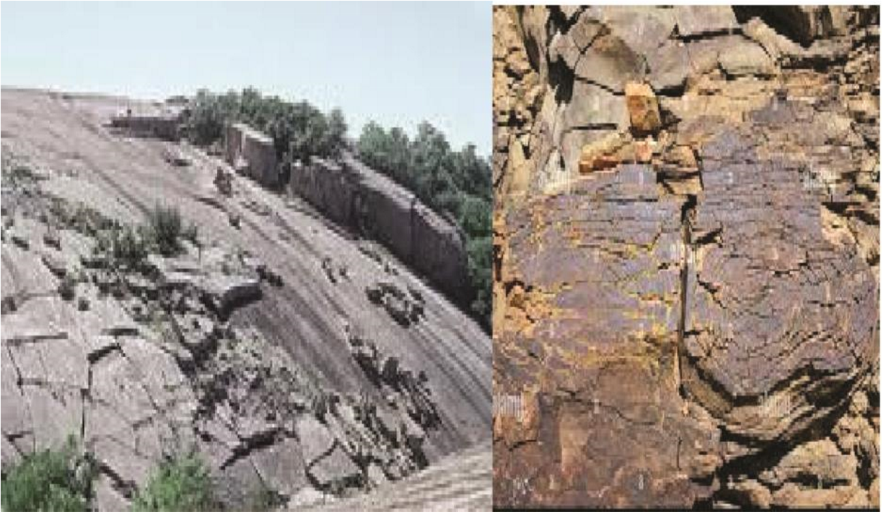

- Block disintegration occur in hot regions and involves breakdown of jointed rocks into rectangular shaped blocks due to heating during day causing expansion and cooling at night causing contraction.
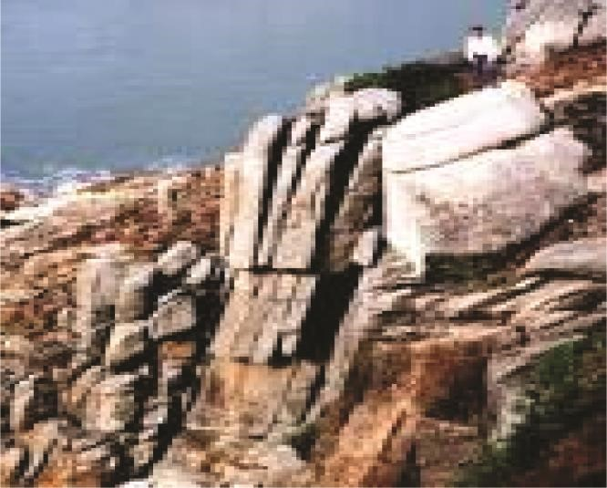
- Granular disintegration is a form of physical weathering where a rock breaks into small particles called granules. It is mainly observed in rocks with different colored minerals such granite rocks constitute of mica, quartz and feldspar which have different heat absorption and linear expansivity capacities. Granular disintegration is found at Mubende and Nakasongola in Uganda, Turkana in Kenya, etc.

- Aridity shrinkage or slaking occurs on non-porous rocks like clay which absorbs water during rainy season and expands, while during dry season lose water through evaporation and crack. Repeated alternative expansion and contraction eventually cause them to crumble into small elongated pieces. This kind of weathering is common in swamps or areas with clay such as Masai-mara plains in Kenya, Nakasongola and Tororo in Uganda.

- Frost wedging/Frost shattering occurs in places where temperature falls below 0⁰C such glaciated mountain tops of Kilimanjaro, Kenya and Rwenzori. During day snow or ice melts and water enters into rock cracks. During night water in these cracks solidifies and expands causing pressure that breaks rocks into small pieces.

- Pressure release/unloading takes place on granite or metamorphic rocks. Expansion and cracking takes place because large shear stresses under the surface that bends leading to exfoliation of rocks/spalling/sheeting. This form of mechanical weathering can be caused by freezing and thawing, unloading, thermal expansion and contraction, or salt deposition. It common on Nakasongola and Mubende Inselbergs.
- Unloading/ pressure release while is the process by which newly exposed rock due to mass wasting expand and break due to release of weight caused by pressure.

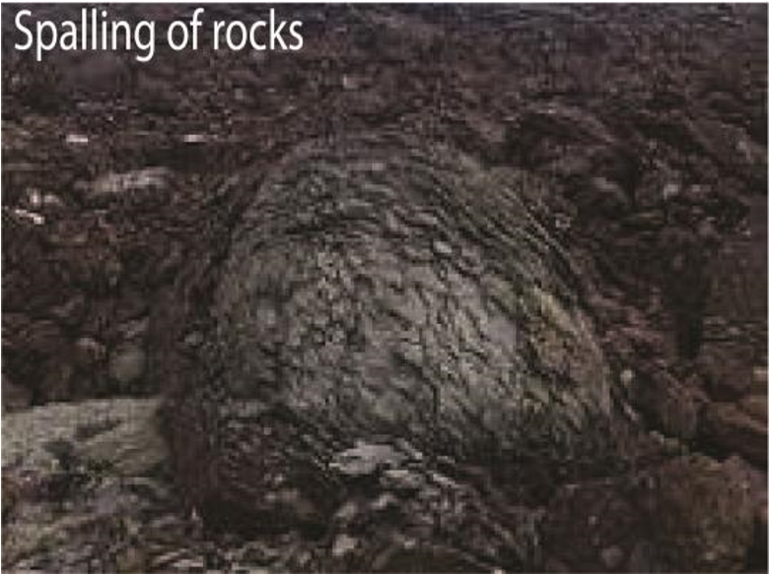
- Salt crystallization which is process where saline solutions in rock cracks and joints begin to crystallize causing stress on the rock resulting into its disintegration

The factors that cause physical weathering
  - Climate
    - In areas of hot climate such as Turkana region in Northern Kenya, Central Tanzania, during the day it is hot, exposed rocks are heated leading to expansion of the rock, while during the night, temperatures rapidly fall leading to rapid cooling of rock resulting into contraction. Such alternate expansion and contraction of a rock lead to peeling or breaking of the rock through processes like exfoliation, granular disintegration, block disintegration etc.
    - In Semi - Arid areas such as Central Tanzania, during the short rainy season, nonporous rocks like clay absorb water and expand while during the long dry season they lose water and crack resulting into rock disintegration..
    - In Semi- Arid areas there is limited cloud cover which leads to temperature fluctuations i.e. hot/very hot during the day, cool/cold during the night leading to expansion and contraction, resulting into breakdown of rocks.
    - On high mountains of East Africa, the temperature fluctuations result into frost weathering which is the process by which water collects in cracks during the day and during the night water freezes, volume increases causing pressure and breaking of the rock
  - Nature of parent rock.
    - Jointed rocks such as limestone in Turkana, Kotido and Moroto areas result into block disintegration when rocks break into rectangular blocks when repeatedly heated or cooled.
    - Mineral composition- Rocks having different minerals absorb heat and lose heat at different rates when heated or cooled respectively resulting into granular disintegration.
    - Color of the rock- dark colored rocks absorb a lot of heat in Semi - Arid areas when heated leading to their disintegration.
    - Differences in rock hardness. Soft rocks such as limestone in semi-arid areas like Turkana, Kotido easily break down when exposed to rapid cooling and contraction due to hot temperatures during day and cold during the night.
  - Relief
    - Steep slopes tend to experience a lot of soil erosion that expose rocks to process of physical/mechanical weathering.
    - Steep slopes tend to be affected by mass wasting that expose the rock to unloading/pressure release which is in form of mechanical weathering.
    - Limited vegetation cover in semi-arid areas like Turkana, central Tanzania, Moroto exposes the rock to extreme temperature fluctuation resulting into rapid expansion during day and rapid contraction at night leading to rock disintegration.
  - Biotic factors
    - Movement of heavy animals like elephants, antelopes, zebra in Kidepo National Park lead to breaking of rocks
    - Burrowing animals like squirrels, Hog and insects like locust, termites destroy vegetation thus exposing rocks to physical weathering due to temperature fluctuations.
    - Effects of plants adapted to semi-arid areas like cactus, acacia grow strong roots into and break rocks
    - Human activities such as quarrying cause disintegration of rock • Time: the longer the time the more physical weathering occurs.

Chemical weathering
Chemical weathering is the decomposition of rocks due to chemical reaction that takes place between the rock minerals, water and atmospheric gases like oxygen and carbon dioxide causing changes in chemical composition. Chemical weathering dominates areas of heavy rainfall and high temperatures such as L. Victoria basin, Kigezi highlands, Kenya highlands, coastal areas like Mombasa.

Types of chemical weathering

Solution
This is where soluble mineral components in rocks are dissolved by water e.g. rock salts are carried in solution leaving behind joints, cracks/widened hollows in rocks. Oxidation
This is the reaction between oxygen and mineral components in rocks such as iron, aluminum facilitated by the hot temperatures and existence of water. This has led to the formation of laterites for example on the flat-topped hills of Buganda, Rocks containing Iron (ferrous state) change to ferric state. Hydrolysis
This is the reaction between the hydrogen ions from water and mineral ions from rocks to form new compounds. It the major process in of decomposition of feldspars in igneous rocks e.g. granite.
Carbonation
This involves rain water dissolving atmospheric carbon dioxide to producing carbonic acid. This reacts with calcium and magnesium carbonates in the rocks to form to form soluble bicarbonates that are lost in solution.
Hydration
This is a process in which certain minerals absorb water and expand causing internal stress and fracturing of the rock. Examples include the conversion of hematite to limonite, mica in sedimentary rocks like sandstone.
Spheroidal weathering
This is the swelling/expansion of the outer shell of a rock mass by penetration of water forcing them to expand, loosen and peel successively away.
Reduction/gleying
It is the removal of oxygen from a substance or addition of hydrogen to it, It occurs in swampy/water logged areas at the shores of lake Victoria. It involves aerobic bacteria absorbing the limited oxygen leaving behind hydrogen that reacts with the rocks to form new compounds i.e. the clay rich rocks turn into blue greyish colour.
Chelation
This involves Base Exchange between plants and rocks which cause chemical changes and rock disintegration.
The factors that favor chemical weathering

Mineral composition of the rock
- Rocks that contain calcium carbonate/limestone dissolve in water that contain carbonic acid
e.g. at Tororo in eastern Uganda and Nyakasura
- Rocks like feldspar hydrolyze in water into other compounds such as potassium ions, kaolinite (clay) and silica.
- Rocks that contain iron are oxidized in presence of water and oxygen.
- Rock-salt (halite), gypsum and limestone (including chalk)dissolve in presence of water.
- Igneous rocks are easily hydrated and hydrolyzed because they are composed of silicate minerals, such as quartz and feldspar which readily combines with water.

Nature of rocks
Presence of cracks in jointed rocks increases surface area to agents of chemical reaction
Permeable rocks allow water and oxygen to penetrate leading to hydrolysis and/or oxidation

Climate
- Rainfall provides water for hydrolysis of rocks
- High temperature speeds up chemical reaction in rocks Relief
- Chemical weathering is dominant on gentle slope and low land because these allows percolation of water in the rocks to allow chemical weathering
- Steep slopes promotes removal of weathered materials by erosion exposing rocks to agents of chemical weathering
Biotic factors
- Plants produce humic acid that facilitate rock decomposition
- Man influences chemical weathering by releasing acidic gases/substances to the atmosphere which cause acidic rain/water. Acidic water promotes hydrolysis of rocks
Time
The longer the time the more physical weathering occurs

Landforms resulting from chemical weathering in East Africa These include

Stalactite and stalagmite
These are formed through carbonation. Rain water combines with carbon dioxide in the atmosphere to form weak carbonic acid which dissolves calcium carbonate to form calcium bi carbonate. When solution reaches underground cave, calcium carbonate is deposited on roof of the cave to form stalagmite e.g. at Nyakasura in Western Uganda.
Pillars
These are vertical stands of calcium carbonate formed in underground caves when stalactites and stalagmites continue to grow towards each other and eventually join. Examples arc found at Nyakasura and Tanga. Caves
A cave is a natural underground space. It is formed when there is chemical dissolution of limestone or dolomite. The rock is dissolved by natural acid in ground water that seeps through the bedding planes, faults and joints.
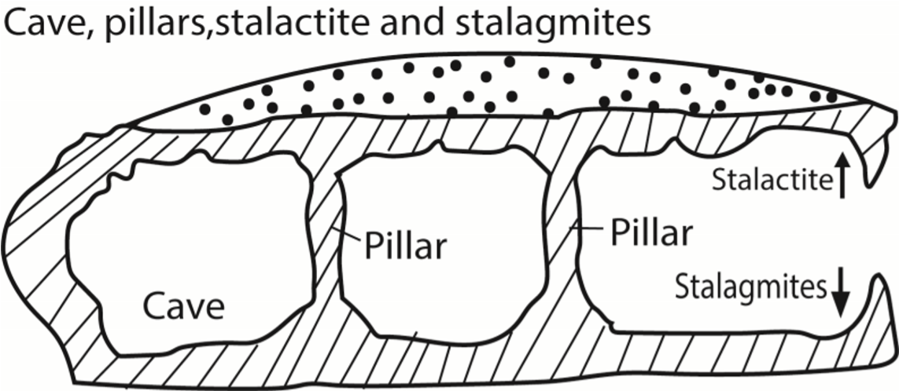

Grikes and Clints
Grikes are hollows or depressions while Clints are ridges formed as a result of carbonation. They formed in limestone areas with rocks of different chemical composition. Lime stone is dissolved by acidic rain to form depressions/ hollows called Grikes while dissolved rocks form ridges called Clints/ Limestone pavement.
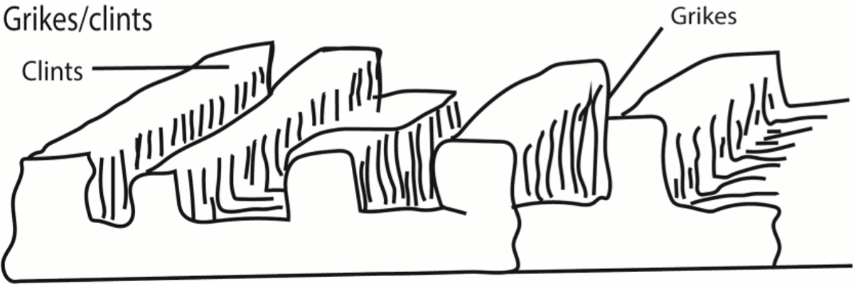
Examples are found on the western side of Tororo rock, Karasuka in Karamoja, Nyakasura etc.

Arenas/Sink holes
A sink hole is a natural depression or hole in earth’s surface formed when lime stone is dissolved. It is formed through the processes of removal of soluble rock by percolating water and the collapse of roof cave.
Dolines:
These are larger than sinkholes. These are shallow circular depressions formed either by solution of the surface lime stone or by collapse of underlying caves. In latter case they are called collapse doline.
Polje.
This is an elongated basin having a flat floor and steep walls. The poljes are formed by coalescence of several sinkholes when being formed through carbonation and solution. In some poljes, small residual hills known as hums are formed.
Limestone gorge is deep steep-sided valley formed when acid rain seeps into the cracks in limestone rocks or when a larger river erodes/ weathers soft limestone rocks by solution. Duricrust is a hard crust (layer) found on the surface formed from mineral precipitation i.e. deposition of insoluble materials from a solution. The most common in East Africa is lateritic duricrust formed when the weathered layer become impregnated with iron solution due to leaching. On removal of top layer laterite hardens into duricrust like on flat topped hills of Buganda/ laterite terms·. , - -·.,._
Tors are landforms created by chemical weathering of a rock along joints followed by removal of the weathered material.

Differences between physical and chemical weathering
- In physical weathering there is no change in the chemical nature of the rocks that are broken into small particles while in chemical weathering there in a change in chemical composition of a rock
- Physical weathering occur in form of block disintegration, exfoliation, granular disintegration, frost weathering while chemical weathering involves decomposition/decay of rocks into new compounds by reactions like oxidation, hydrolysis, hydration etc.
- Physical weathering commonly occur in arid areas with high temperature fluctuation while chemical weathering commonly occur in areas of adequate rainfall
- Physical weathering no new compounds formed while chemical weathering new compounds are formed
Biological weathering: Breakdown caused by living organisms.
Examples: Plant roots cracking rocks, lichens producing acids, burrowing animals.
Soil Profile
A soil profile is the vertical section of soil that shows all its layers (called horizons) from the surface down to the parent material. It reveals the history of soil formation and is essential for understanding soil fertility, drainage, and land use.

Soil horizons
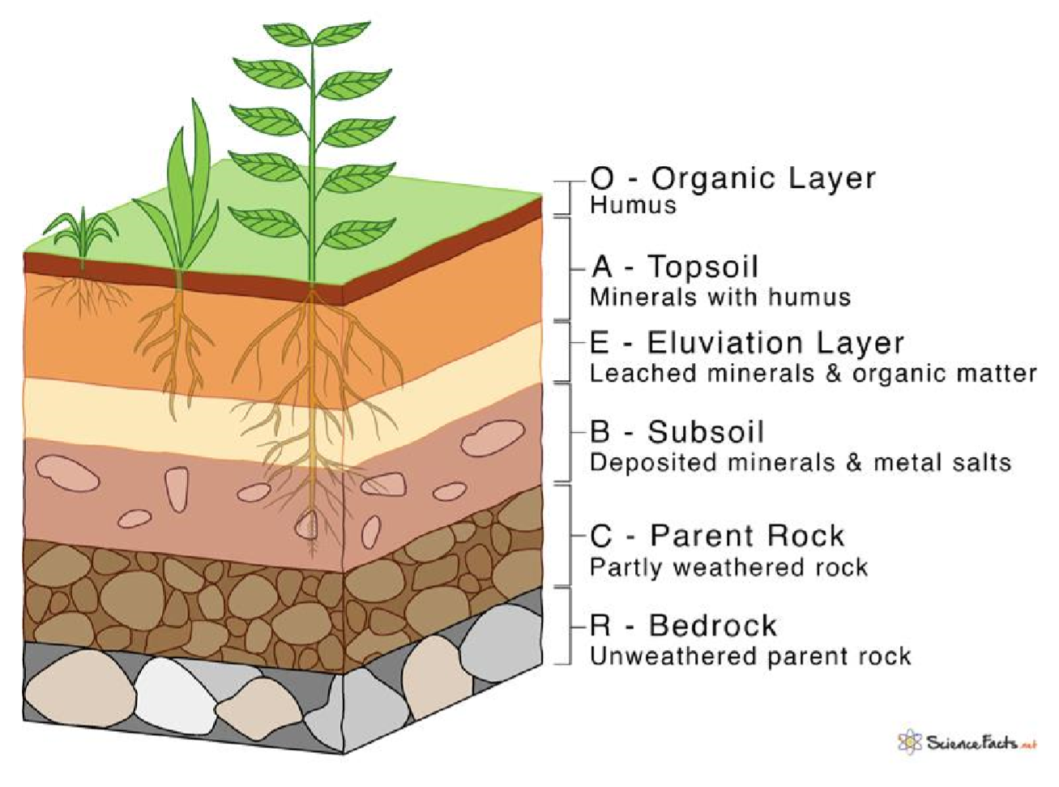

Features of soil horizons
- O Horizon (Organic layer):
  - Composed of leaf litter, decomposed plants, and organic matter. • Dark in color, rich in nutrients.
- A Horizon (Topsoil):
  - Mixture of minerals and organic matter.
  - Zone of root growth and high biological activity. • Most fertile layer for crops.
- E Horizon (Eluviation layer):
  - Light-colored, sandy layer.
  - Minerals and nutrients leached downward by water.
- B Horizon (Subsoil):
  - Zone of accumulation (illuviation).
  - Contains clay, iron, and other minerals washed down from above. • Less organic matter, denser than topsoil.
- C Horizon (Parent material):
  - Weathered rock fragments.
  - Little biological activity.
  - Source of minerals for upper horizons.
- R Horizon (Bedrock):
  - Unweathered rock beneath the soil. • Foundation of soil formation.

Soil Profile Horizons and Their Land Use Implications
Horizon | Characteristics | Land Use Importance
O Horizon (Organic layer) | Rich in decomposed plant material, dark color | Supports forestry, grazing, and organic farming
A Horizon  (Topsoil) | Fertile, high biological activity, root zone | Best for crop cultivation and gardening
E Horizon  (Eluviation layer) | Leached, lighter color, low nutrients | Often unsuitable for intensive farming, may need fertilization
B Horizon (Subsoil) | Accumulated clay, iron, minerals | Important for water storage; affects deep-rooted crops
C Horizon (Parent material) | Weathered rock fragments | Determines long-term soil fertility and mineral supply
R Horizon  (Bedrock) | Solid rock | Limits rooting depth; influences construction and engineering projects
How Soil Profile Influences Land Use
- Agriculture: o Thick, fertile A horizons → ideal for farming.
o Shallow soils with exposed bedrock → poor for crops, better for grazing or forestry.
- Forestry: o Deep organic and nutrient-rich layers support tree growth.
- Construction: o Soil depth and stability (B and C horizons) determine suitability for building foundations.
- Water management: o Subsoil layers (B horizon) influence drainage, irrigation, and groundwater recharge.
- Conservation: o Soil profiles help identify erosion risks and guide reforestation or terracing.
Key Considerations
  - Land use must match soil profile characteristics to avoid degradation.
  - Misuse (e.g., farming on shallow or sandy soils) can lead to erosion, nutrient loss, and reduced productivity.
  - Sustainable practices (crop rotation, mulching, agroforestry) maintain soil horizons and extend land use potential.
The conditions that influence soil profile development
- Nature of the parent Rock
  - Hard rocks which are not easily weathered such as granite lead to formation of thin soils and poorly developed profiles while soft rocks which are easily weathered such as volcanic ash and limestone lead to the development of a deep soil profile.
  - Rocks with joints and cracks are also easily broken down to produce deep/mature soil profiles as compared to those without
  - Dark coloured rocks responsive to heat are also easily weathered to produce deep /well developed profiles as compared to light coloured rocks which are difficult to break up.
  - Basic igneous rocks which are difficult to weather as well as some sedimentary rocks (composed of previously weathered materials are difficult to breakdown and produce shallow soils in immature/ poorly developed soil profiles.
' Permeable/ porous rocks are easily weathered by chemical processes to produce deep mature soil profile as compared to impermeable rocks which may produce shallow soil profiles etc.
- Climate
  - It determines the character and rate of weathering.
  - In hot humid climates, chemical weathering occurs at a fast rate leading to the formation of deep soils and well developed/ mature soil profiles.
  - In hot dry climates physical weathering predominates leading to the formation of thin/ skeletal soils/ azonal soils which do not have well developed profiles.
- Vegetation
  - Thick vegetation cover decays and leads to the formation of humus which is added to horizon A of the soil profile
  - Plant roots also lead to the disintegration of rocks and the formation of soil in a soil profile.
  - Forested areas such as Mabira, Kakamaga, Kissi in Kenya therefore tend to have deep soils in well- developed profiles while areas with thin vegetation cover have thin skeletal soils and poorly developed profiles.
- Drainage
  - Water logged conditions do not allow the easy development of a soil profile such as Lutembe wetlands, Katonga, Awoja wetlands, etc.
  - Well drained areas lead to the formation of a well-developed mature soil profile such as areas around L. Victoria
- Human activities
  - Such as mining, quarrying, road construction etc. lead to the breakdown of rocks and the formation of deep soils characteristic of well-developed profiles e.g. mining in Tororo, cultivation around L. Victoria.
- Living organisms
  - In the soil such as ants, earthworms and mammals like rats and moles also break down rocks as the construct their passages underground leading to the formation of deep soils and well developed soil profiles
- Time
  - Ample time is required to the formation of mature, fertile and deep soils in a welldeveloped soil profile.
  - If time is short immature/ azonal soils will formed with poorly developed /shallow soil profiles.
- Topography.
  - Steep-s lopes are- more susceptible to soil erosion, and thin soil profile
  - Gentle slopes - erosion is slower, there is a lot of deposition of soil eroded on steep slopes and water percolates to assist in soil profile development leading to deep, mature soil profile.
  - Valleys; lowlands; extensive deposition and percolation of water lead to deep mature soil profiles where there are waterlogged conditions there is immature soil profile.

The Soil Catena

Catena means a chain or connected series
A soil catena is the natural sequence of different soil types that occur down a slope, all formed under the same climate and from the same parent material, but differing because of topography, drainage, and erosion/deposition patterns. Features soil catena
- Same parent material: All soils originate from the same rock or sediment.
- Same climate: They form under identical climatic conditions.
- Variation due to slope: Differences arise from drainage, erosion, and deposition.
- Linked sequence: Each soil type is related to the next, forming a chain across the slope.
An example of the soil catena from Buganda shows the following soil types, at the top is laterite/lateritic capping characterized by thin skeletal soils; follwed by a vertical slope/free face with bare rock; followed by concave slope with deep loam soils and lastly in the broad valleys are fine clay soils rich in organic matter.
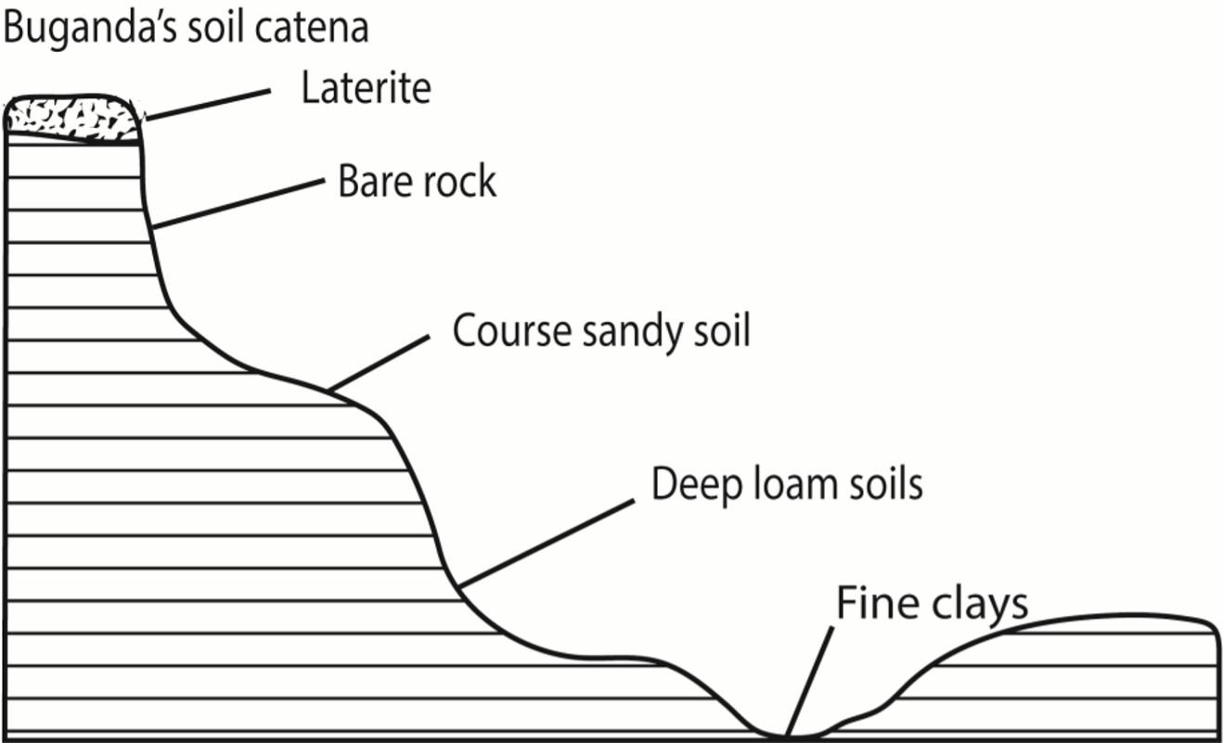

The factors which have led to the development of soil catena in East Africa

Relief
The nature of a slope/topography influences the development a soil catena for example in Buganda the hill top/ridge tends to accumulate organic matter that allows formation of an adequate thickness of soil. Steeper slope or crest sections tend to be freely drained, while at the bottom of slopes or toe slopes there is usually higher in moisture content due to poor drainage. Toe slope soils are not only higher in moisture content, but are also known to be richer in clay and organic matter.

Drainage
The moisture content of the soil influences the development of the catena as soil changes along the slope. Well drained mature soils are found on the gentle slope while thin, stony dry, immature soils are found on the steep slopes. Clay/boggy soils are generally found in the valley bottoms where drainage is poor/water logged.

Nature of parent rock
The characteristics of parent rock in terms of hardness, porosity, structure etc. will determine the rate of erosion thereby influencing the type of soil formed downslope. In addition the different soil along the slope could be the result of different parent materials.

Human activities
Man’s activities like deforestation, settlement, agriculture etc. result in removal of surface vegetation which encourage erosion on the upper slopes and deposition on the lower slopes.

Vegetation cover
Soil catena development is faster in areas without vegetation cover since the rate of erosion is fast. Thick vegetation slow down the rate of erosion and the rate of soil catena development.
Time
Time is required to form a well developed soil catena
Climate
Heavy rainfall in East Africa in areas around Lake victoria promote leaching leading to the development of lateritic soils at the hill top. Heavy rainfall encourage erosion on the upper slopes and deposition on the lowers slopes and valleys. Water logging due to heavy rainfall results in clay soils.

Soil Productivity
Soil productivity refers to the capacity of soil to support plant growth and yield crops sustainably. It is a measure of how well soil can provide essential nutrients, water, and a suitable environment for roots and microorganisms.
Differences between soil fertility and soil productivity
Aspect | Soil Fertility | Soil Productivity
Meaning | Ability to supply nutrients | Ability to produce crops/yields
Focus | Nutrient status & soil chemistry | Actual crop output
Nature | Potential property | Realized property
Influenced by | Nutrients, pH, organic matter | Fertility + climate, irrigation, technology, management
Measurement | Soil tests (nutrient levels, pH) | Crop yield per unit area
Example | A soil rich in nutrients but waterlogged (fertile but unproductive) | A soil with moderate fertility but wellmanaged irrigation (productive)
Key Insight
- All productive soils must be fertile, but not all fertile soils are productive.
- Productivity is broader — it includes fertility plus external factors like climate, irrigation, and farming practices.
Factors Affecting Soil Productivity
- Soil fertility: Availability of nutrients (N, P, K, micronutrients).
- Soil texture & structure: Influences water retention, aeration, and root penetration.
- Soil depth: Deeper soils allow better root development and water storage.
- Soil pH: Controls nutrient availability and microbial activity.
- Organic matter: Improves structure, water-holding capacity, and nutrient cycling.
- Moisture & drainage: Balanced water supply is vital for crops.
- Biological activity: Microbes and fauna enhance nutrient cycling and soil health.
Importance of Soil Productivity to Farmers
- Food security: Productive soils ensure reliable crop yields, supporting local and global food supplies.
- Economic stability: Higher productivity reduces input costs (fertilizers, irrigation) and increases profits.
- Sustainability: Maintaining soil productivity through practices like crop rotation and organic amendments prevents long-term degradation.
- Resilience: Productive soils buffer against droughts and climate variability by retaining water and nutrients.
Importance of Soil Productivity to Foresters
- Tree growth: Soil productivity determines forest health, timber quality, and regeneration capacity.
- Biodiversity: Productive soils support diverse plant species, which in turn sustain wildlife habitats.
- Carbon storage: Healthy, productive soils enhance carbon sequestration, mitigating climate change.
- Sustainable forestry: Productivity guides reforestation, afforestation, and forest management practices.
Importance of Soil Productivity to Environmentalists
- Ecosystem services: Productive soils regulate water cycles, filter pollutants, and support biodiversity.
- Climate regulation: Soil productivity is linked to carbon cycling and greenhouse gas balance.
- Land conservation: Protecting soil productivity prevents erosion, desertification, and land degradation.
- Human well-being: Productive soils underpin sustainable development, balancing agriculture, forestry, and conservation needs.
Measures to improve soil productivity
- Add organic matter: Incorporating compost, manure, or green manure improves soil structure, water retention, and nutrient cycling.
- Balanced fertilization: Applying the right mix of macro- and micronutrients prevents nutrient depletion and supports healthy crop growth.
- Crop rotation: Alternating crops reduces pest buildup, improves soil fertility, and enhances biodiversity.
- Cover cropping: Planting legumes or grasses between main crops prevents erosion, adds nitrogen, and improves soil organic matter.
- Erosion control: Techniques like terracing, contour plowing, and mulching protect topsoil from being washed away.
- Irrigation management: Efficient water use prevents salinization and ensures crops receive adequate moisture.
- pH adjustment: Liming acidic soils or adding sulfur to alkaline soils optimizes nutrient availability.
- Reduced tillage: Minimizing soil disturbance preserves structure, reduces erosion, and maintains microbial activity.
- Agroforestry: Integrating trees with crops improves soil fertility, reduces erosion, and enhances biodiversity.
Soil Degradation

Soil degradation is the decline in soil quality and productivity due to natural processes and human activities.
Effects soil degradation
- Reduced soil fertility and crop yields.
- Loss of biodiversity and soil organisms.
- Increased flooding and desertification.
- Threats to food security and livelihoods.
Causes of soil degradation
- Erosion: Loss of topsoil by wind and water.
- Nutrient depletion: Continuous cropping without replenishment.
- Salinization: Build-up of salts from poor irrigation practices.
- Acidification: Excessive use of chemical fertilizers or acid rain.
- Pollution: Contamination by industrial waste, pesticides, and heavy metals.
- Deforestation: Removal of vegetation cover, exposing soil to erosion.
- Overgrazing: Livestock pressure reduces vegetation and compacts soil.
Soil Conservation
Soil conservation refers to practices that protect, maintain, and restore soil health to ensure long-term sustainability.

Measures for soil conservation
- Afforestation & reforestation: Planting trees to protect soil from erosion.
- Contour farming: Plowing along slope contours to reduce runoff.
- Terracing: Creating steps on slopes to slow water flow.
- Cover cropping: Growing plants to protect soil between main crops.
- Crop rotation: Alternating crops to maintain fertility and reduce pests.
- Organic amendments: Adding compost or manure to improve soil structure.
- Mulching: Covering soil with plant residues to retain moisture and reduce erosion.
- Controlled grazing: Managing livestock to prevent overgrazing.
- Efficient irrigation: Prevents salinization and waterlogging.
Case study of the nature, causes, effects and control measures soil degradation from a developed country
A strong case study of soil degradation in a developed country is the Dust Bowl in the United States (1930s). It illustrates how poor land management combined with climatic extremes led to massive soil erosion, crop failure, and migration. Control measures like conservation farming, reforestation, and sustainable land management were later introduced to restore productivity.

Case Study: The Dust Bowl (USA, 1930s) Nature of Soil Degradation
- Severe wind erosion stripped away millions of tons of topsoil.
- Vast areas of farmland became barren and unproductive.
- Soil fertility declined drastically, leading to widespread crop failure.
Causes
- Over-cultivation: Farmers plowed large areas of prairie grassland for wheat production.
- Monocropping: Continuous wheat cultivation depleted soil nutrients.
- Lack of conservation practices: No crop rotation, cover crops, or windbreaks.
- Climatic factors: Prolonged drought and high winds exacerbated erosion.
Effects
- Agricultural collapse: Crop yields dropped sharply, leading to food shortages.
- Economic hardship: Thousands of farmers lost livelihoods, triggering mass migration (the “Okie” migration to California).
- Environmental damage: Dust storms destroyed ecosystems, reduced biodiversity, and worsened air quality.
- Social impact: Rural communities were devastated, increasing poverty and unemployment.
Control Measures
- Soil Conservation Service (1935): Established to promote sustainable farming.
- Contour plowing: Reduced runoff and erosion.
- Crop rotation & cover cropping: Restored soil fertility and organic matter.
- Shelterbelts (windbreaks): Trees planted to reduce wind erosion.
- Reforestation & grass reseeding: Helped stabilize soils and restore ecosystems.

Case study of the nature, causes, effects and control measures soil degradation from a developing country
A clear case study of soil degradation in a developing country is Punjab, India, where intensive agriculture, overuse of chemical inputs, and poor land management have led to severe soil fertility decline, erosion, and salinization. Control measures include crop diversification, organic amendments, and sustainable irrigation practices.
Case Study: Soil Degradation in Punjab, India Nature of Soil Degradation
- Decline in soil fertility due to nutrient depletion.
- Widespread salinization and waterlogging from excessive irrigation.
- Soil erosion in cultivated areas.
- Loss of organic matter and microbial diversity.
Causes
- Intensive monocropping: Continuous wheat–rice rotation depletes nutrients.
- Excessive chemical fertilizer use: Leads to soil acidification and micronutrient imbalance.
- Over-irrigation: Causes waterlogging and salinity buildup.
- Deforestation & habitat destruction: Reduced vegetation cover accelerates erosion.
- Population pressure: Expanding agriculture without conservation practices.
Effects
- Reduced crop yields: Declining productivity threatens food security.
- Economic stress: Farmers face higher costs for fertilizers and irrigation.
- Environmental damage: Loss of biodiversity, soil organisms, and increased greenhouse gas emissions.
- Health impacts: Contaminated water from fertilizer runoff affects rural communities.
- Long-term sustainability risk: Soil degradation undermines agricultural resilience.
Control Measures
- Crop diversification: Moving away from wheat–rice monocropping to pulses, oilseeds, and vegetables.
- Organic amendments: Use of compost, manure, and green manures to restore fertility.
- Balanced fertilization: Incorporating micronutrients and reducing chemical dependency.
- Efficient irrigation: Adopting drip irrigation and reducing groundwater overuse.
- Agroforestry & afforestation: Planting trees to stabilize soil and improve biodiversity.
- Government policies: Soil health cards, subsidies for organic inputs, and awareness campaigns.
Revision questions
- Examine the weathering processes taking place in East Africa.
(Define weathering, identify and describe each weathering types, give occurrence of each type of weathering in East Africa))
- Physical weathering dominates in the arid areas of East Africa. Discuss
(Define physical weathering, identify arid areas in East Africa, factors that promote the types of physical weathering in East Africa, describe chemical weathering as alternative to physical weathering)
- (a) Distinguish between physical and chemical weathering
(Define the terms physical and chemical weathering and then give differences between physical and chemical weathering)
  - Describe the factors which have favored chemical weathering in East Africa.
- Describe the chemical weathering process in humid areas in East Africa
(Define the term chemical weathering, identify humid areas in East Africa, describe factors that favored chemical weathering, describe chemical weathering processes)
- Examine the factors that influence the type and rate of weathering in East Africa
(Define weathering, identify the types of weathering, then explain the factors that influence the type and rate of weathering)
- To what extend does the rate and character of weathering depend on the nature of rocks? (Define weathering, bring out the extent to which the nature of rocks (mineral composition, rock hardness, color of rock, rock joints) influence the character of rate of weathering; discuss the alternative/other factors that affect the rate of weathering as well)
- (a) distinguish between physical and chemical weathering
  - Examine the importance of weathering process on landform formation in East Africa
- Account for the landform produced by carbonation process in East Africa
- (a) What is chemical weathering
  - Describe the landforms resulting from chemical weathering
- Examine the weathering processes that take place in the L. Victoria basin of East Africa. (Define weathering, identify location of L. Victoria basin, discus both chemical and physical weathering process.

